California State University Fullerton

CPSC 462



Object Oriented Software Design

Supplementary Specification

for the

1. Update placeholder with your project’s title being careful not to delete the (potentially hidden) bookmark. If you did it right, the document’s footer will be updated too
2. Delete this bubble

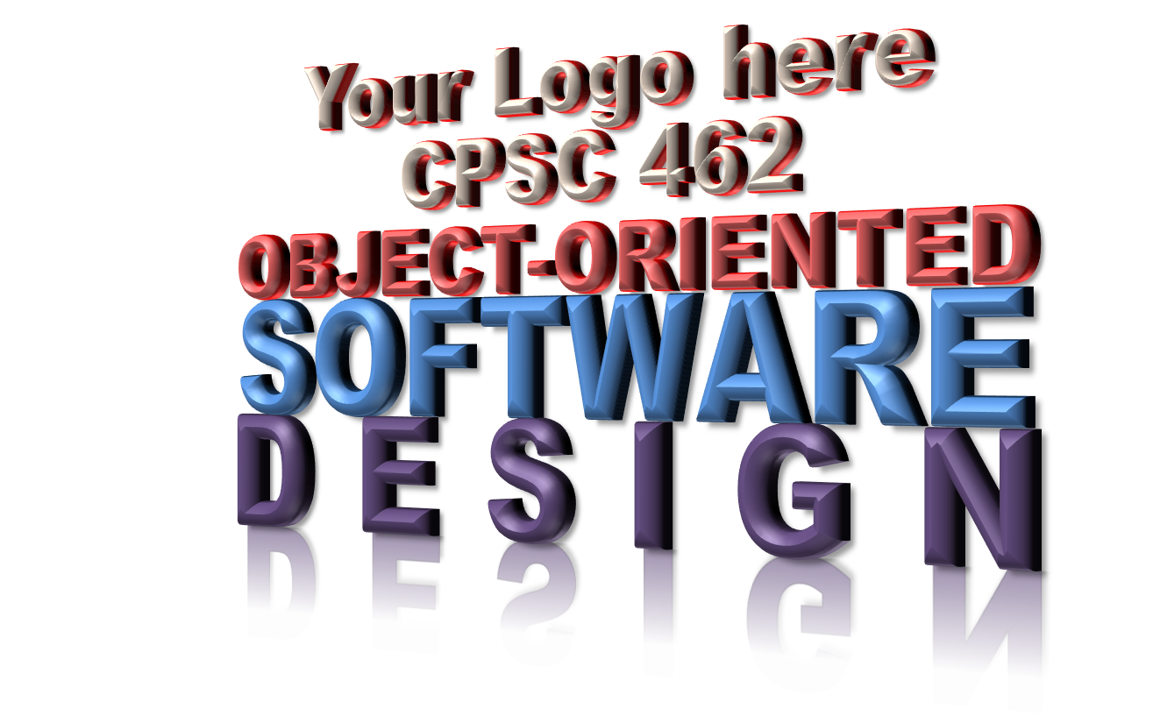

<Your Project Title here>

System

|  |  |  |
| --- | --- | --- |
| **<Student Name 1 here>** | **<Student Name 2 here>** | **<Student Name 3 here>** |
| <Title / Roll within project> | <Title / Roll within project > | <Title / Roll within project > |
| <[Email1@csu.fullerton.edu](mailto:Email1@csu.fullerton.edu)> | <[Email2@csu.fullerton.edu](mailto:Email2@csu.fullerton.edu)> | <[Email3@csu.fullerton.edu](mailto:Email3@csu.fullerton.edu)> |

Revision History:

| Version | Date | Summary of Changes | Author |
| --- | --- | --- | --- |
| 1.0 | <date of release> | * Initial Release | <Name 1>  <Name 2>  … |
|  |  |  |  |
|  |  |  |  |
|  |  |  |  |

Table of Contents

1 Introduction and Purpose 1

2 Feature Requirements List 1

3 Functionality (common across UCs) Requirements 1

3.1 System Event Logging Requirements 1

3.2 Security Requirements 1

3.3 Other Requirements 1

4 Quality Attribute Requirements 1

4.1 Usability Requirements 1

4.2 Reliability Requirements 1

4.3 Performance Requirements 1

4.4 Supportability Requirements 1

4.5 Adaptability Requirements 1

4.6 Configurability Requirements 1

5 Implementation Constraint Requirements 2

6 Purchased Component Requirements 2

7 Free Open Source Component Requirements 2

8 Interface Requirements 2

8.1 Noteworthy Hardware and Hardware Interface Requirements 2

8.2 Software Interface Requirements 2

9 Application-Specific Domain (Business) Rule Requirements 2

10 Legal Requirements 3

11 Information in Domains of Interest 3

12 Report Requirements 3

12.1 <Report 1 Title> 3

12.1.1 Description 3

12.1.2 Format and Content Requirements 3

12.2 <Report 2 Title> 3

12.2.1 Description 3

12.2.2 Format and Content Requirements 3

13 Packaging Requirements 3

14 Technical Standards Requirements 3

NOTE TO STUDENTS:

1. See Larman §7.4 Next Gen Example: (Partial) Supplementary Specification and §7.5 Commentary: Supplementary Speciation
2. Remember this is a reequipments document, not a wish list. Requirements shall be written in proper “requirement” style with shall statements.
3. Requirements must be testable. Avoid words like “The system shall be performant.” as that is not testable. Be sure to provide measure requirements, like “The system shall respond within 100 milliseconds after receipt of a request.”
4. Avoid words like “will” or “should”
5. Delete this NOTE before you deliver

# Introduction and Purpose

…

# Feature Requirements List

* …
* …

# Functionality (common across UCs) Requirements

## System Event Logging Requirements

…

## Security Requirements

…

## Other Requirements

…

# Quality Attribute Requirements

## Usability Requirements

…

## Reliability Requirements

…

## Performance Requirements

…

## Supportability Requirements

…

## Adaptability Requirements

…

## Configurability Requirements

…

# Implementation Constraint Requirements

* …
* …

# Purchased Component Requirements

* …
* …

# Free Open Source Component Requirements

* …
* …

# Interface Requirements

## Noteworthy Hardware and Hardware Interface Requirements

* …
* …

## Software Interface Requirements

* …
* …

# Application-Specific Domain (Business) Rule Requirements

NOTE TO STUDENTS:

1. See Larman §7.10 Next Gen Example: Business Rules (Domain Rules) and §7.11 Commentary: Domain Rules
2. I often get asked what the difference is between this section here in the Sup Spec and the rules captured in the General Domain Rules document. The General Domain Rules document captures how a domain or business may operate. They are not requirements of any one application, although an application's requirements are often influenced. This section here in the Sup Spec tailors those general domain rules into real requirements specific to this application. Remember, this is a reequipments document and these rules shall be expressed in well-formed, testable reequipments.
3. Delete this NOTE before you deliver

| ID | Rule (Requirement) | Changeability | Parent Domain Rule ID |
| --- | --- | --- | --- |
|  |  | <describe who has authority to change this reequipments, and how often you anticipate that happening> | <Trace to ID in General Domain (Business) Rules document> |
|  |  |  |  |
|  |  |  |  |
|  |  |  |  |

# Legal Requirements

* …
* …

# Information in Domains of Interest

* … (Example: Pricing requirements)
* … (Example : Credit and Debit Payment Handling)
* …

# Report Requirements

## <Report 1 Title>

### Description

…

### Format and Content Requirements

<Insert a table, form, picture, or whatever makes sense to convey exactly what is on the report and how it is laid out when printed and or displayed. The upper User Interface system layer is responsible for meeting this display requirement and the Domain (Application) Layer is responsible for meeting this hard or soft copy requirement. Either way, here is where those requirements are specified.>

## <Report 2 Title>

### Description

…

### Format and Content Requirements

<Insert a table, form, picture, or whatever makes sense to convey exactly what is on the report and how it is laid out when printed and or displayed. The upper User Interface system layer is responsible for meeting this display requirement and the Domain (Application) Layer is responsible for meeting this hard or soft copy requirement. Either way, here is where those requirements are specified.>

# Packaging Requirements

NOTE TO STUDENTS:

1. Provide packaging requirements. For example, if you offer your customers a download, shall you package the system as a Window’s .msi installation file? A Linux .rpm installation file? Will you require separate downloads, one for the executable system and another for data? How is the data packaged? As an Oracle backup? As a text DDL SQL file?
2. How do you handle licensing in your packaging? Is that a separate transaction?
3. If you package as physical media, how are your media requirements? For example, trademarks, copyright, encryption?
4. Delete this NOTE before you deliver

…

# Technical Standards Requirements

NOTE TO STUDENTS:

1. Site the exact technical specifications for all technologies used in your project by name, date, and version number. Include the technologies both in your delivered system and the things you use to develop and test the system.
2. Delete this NOTE before you deliver

| Title | Release date | Version | Owner |
| --- | --- | --- | --- |
| <Title of document> | <Date document was released> | <Document Version> | <Owning organization of the standard> |
|  |  |  |  |
|  |  |  |  |
|  |  |  |  |